|  |  |
| --- | --- |
| Project title | Separate and Mulitphysics Effects IRPhEP Benchmark Evaluation using SNAP Experiments |
| Federal Grant | DE-NE0009217 |
| Reporting Period | 3th Quarter FY 2023 |
| Contributors | Dan Kotlyar, Georgia Institute of Technology (GT)  Bojan Petrovic (GT), Isaac Naupa (GT)  Ben Lindley (University of Wisconsin-Madison, UW),  Sam Garcia (UW)  Shane Stimpson, BWX Technologies (BWXT),  Mark DeHart, Idaho National Laboratory (INL). |
| Submission Date | 07/25/2023 |

*This page is intentionally blank.*

|  |  |
| --- | --- |
| Project title: | Separate and Mulitphysics Effects IRPhEP Benchmark Evaluation using SNAP Experiments |
| Federal Grant: | DE-NE0009217 |
| Document Number: | NE-9217-GT-2023-Q3 |
| Reporting Period: | 3rd Quarter FY 2023 |
| Submission Date: | 07/23/2023 |

|  |  |
| --- | --- |
|  |  |
|  |  |

This research is being performed under funding received from the U.S. Department of Energy Office of

Nuclear Energy’s Nuclear Energy University Program under contract number DE-NE0009217.



# Executive Summary

The SNAP program used a design-build-test-iterate approach for reactor development. This program yielded a considerable amount of documented experimental data. The two main objectives pursued in the current period are to:

1. **Develop and validate benchmark models of the dry condition critical experiments under no coolant and low power conditions, with the end objective of creating an evaluation complaint with the IRPhE evaluation guide [2].**

We have focused on collecting and documenting engineering drawings as well as collecting detailed description on the reactor tests and input parameters such as dimensions and material loadings. The SNAP-8 Experimental Reactor (S8ER) core included 215 fuel elements accepted for use, of which 211 fuel elements were assembled in the S8ER core. Each fuel rod is in the form of a solid hydride uranium-zirconium alloy.

The following specific tasks were accomplished:

* Collecting thermomechanical properties is work-in-progress but is not reported here as our focus is to validate dry experiments (Task 1.3)
* Develop benchmark models to serve as reference solutions for: critical loadings – dry core (Task 2.2), radial reflector worth and control element calibrations (Task 2.3), and reactivity worth of special fuel rods and absorbers (Task 2.4)

**2. Validate the performance of Serpent and Griffin to model effects against a set of dry experiments.**

A prototype reactor core and reflector assembly manufactured for the SNAP-8 experimental reactor was subjected to a series of dry critical experiments. The following subtasks were carried out:

* Collecting neutron data required for Serpent-Griffin validation (Task 2.1). Serpent was used to generate multi-group cross sections. The Serpent-Griffin two-step computational workflow was used to build a full core model in Griffin.
* Critical loadings - dry core (Task 2.2). These dry experiments were used to validate Serpent and Griffin.

This document serves as a rolling report where dimensions, materials, and general data are updated from previous reports to reflect data used to obtain current and future results. This work will primarily focus on the compilation of Serpent input model, but will also report on results for the critical configuration experiments and reactivity worth values of the special fuel rods and absorbers,

Table of Contents

Executive Summary 4

1. Introduction 7

2. Supporting Computational Frameworks 8

*2.1* Open-Source Database - `*snapReactors`* 8

*2.2* Automated Generation of Inputs - `SIMBA` 9

*2.3* ‘snapReactors’ to ‘SIMBA’ Input File Generation 10

3. Experiments & Physical Data 12

*3.1* General Overview of Experiment 12

*3.2* Experiment Geometry and Measurement Procedures 13

3.2.a Critical Configuration 16

*3.3* Materials 17

*3.4* Temperatures 18

4. Benchmark Models Insufficiency Report 18

*4.1* Verification Studies 18

4.1.a Fuel Element Modeling & Composition Verification 18

4.1.b Active Core Modeling & Composition Verification 21

4.1.c Reflector Modeling & Geometry Verification 22

5. Benchmark-model Specifications 27

*5.1* Model Simplifications 27

5.1.a Unmodeled Components 27

*5.2* Benchmark-model Geometry 27

*5.3* Materials and Benchmark Model 29

*5.4* Expected Benchmark Values 33

6. Calculated Serpent Results 35

6.1.a Critical Configurations 35

6.1.b Special Fuel Worths 35

6.1.c Burnable Poison Coating 38

7. Preliminary 3D Griffin Results 38

8. Summary and Conclusions 41

9. Future work 41

10. Noteworthy Accomplishments 42

11. References 42

Acknowledgments 43

Appendix 1. ANS Winter Conference Paper 44

Appendix 2. IRPhEP Format Guidelines 45

# Introduction

The goal of this project is developing an IRPhEP-styled multiphysics microreactor benchmark evaluation leveraging experimental data from the SNAP program. SNAP systems share similar characteristics to modern microreactor designs such as power output, compact core design, high temperature solid moderators, and alkali-metal working fluid. The resulting benchmark would then be used for validation purposes of specific NEAMS tools for microreactor applications. The end objective is to qualify these tools as design and potential licensing tools in the context of microreactor technology. For this specific project we mainly focus on Griffin [1] and Bison, with potentially utilizing Pronghorn and SAM to perform thermal hydraulic tasks.

The SNAP 8 Experimental Reactor is chosen as the main design for the benchmark as it has the most abundance of experimental data and general documentation. The SNAP10A and SNAP2 systems are also well documented and have a variety of experimental data. Although the latter experiments may also be leveraged the current report focuses solely on the SNAP 8 Experimental Reactor Criticality Experiments [1]. The experiments are separated into the classification of dry-experiments and wet-experiments where dry refers to experiments operated at zero power and no coolant running through the system while wet refers to experiments that observed operational conditions. Here, the data compilation, code-to-code verification, and validation tasks are performed for the dry benchmarks.

The main dry experiments analyzed are the criticality configuration experiments. These experiments focused on various configurations regarding fuel element pattern loading, control drum orientation, and control element worth. The main quantity of interest is the system effective multiplication factor, as previous computational efforts have shown that it is the most difficult to capture [2]. The traditional 2-stage approach is used here where the Monte Carlo, Serpent, code is used to generate data and the core calculations are performed with Griffin [1] – a deterministic finite elements MOOSE-based code. To ensure the fidelity of the pre-generation stage, a reference model is developed and validated against the criticality configuration experiments. Specifications and assumptions used for the reference model are documented and discussed.

This report presents some of the computational frameworks being developed to achieve the goals of the project along with their motivations and impacts with regards to the general nuclear engineering community. In addition, we report presents the verification and validation of specific MOOSE tools including a thorough documentation and compilation of experimental data analyzed.

# Supporting Computational Frameworks

A multiphysics benchmark evaluation compliant with the IRPhEP evaluation guide requires systematic assessments of experimental data with meticulous compilation and documentation. Therefore, we are developing a SFCOMPO styled database and an automated consistent computational sequence for modeling purposes.

The SFCOMPO ***styled database*** will have the following attributes:

* Contain all relevant data for benchmark for various SNAP systems.
* Object orientated structure allowing for clean organization and data handling.
* Inherently dynamic structure that allows easy removal and/or addition of information.
* Post processing methods that are easily translated to model inputs in Serpent and Griffin.

The ***automated multiphysics sequence*** will have the following attributes:

* Provide set of functions and utilities for common workflows in reactor based multiphysics analysis.
* Aid in modeling sensitivity studies used for demonstrating the accuracy and quantifying the error or bias uncertainty of reactor physics calculations.

Both developments take the form of python-based packages with proper documentation, error checking, and unit testing. The SFCOMPO styled databased package is called ‘snapReactors’ while the package supporting the automated multiphysics sequence is called ‘SIMBA’ (Serpent Interface for Multiphysics Based Applications). These packages are open source and are hosted on public repositories for use of the nuclear engineering community.

The snapReactors-SIMBA workflow is developed to facilitate the creation of Serpent input files to be used in multiphysics applications. The Serpent input files can be become intricate and extensive when dealing with large problems that require different physical phenomena to be captured. This necessitates SIMBA to make the workflow more practical when doing these types of analyses. snapReactors is a database that hosts well documented experimental data for a variety of reactors under the SNAP Program [1]. Currently, a snapReactors-SIMBA workflow has been established, which takes data directly from the snapReactors database and creates tailored Serpent input files. This workflow facilitated the development of benchmark models evaluating critical loadings, radial reflector reactivity worth values and control element calibrations, and reactivity worth values of special fuel rods and absorbers. This work is in the process of publication though critical loading and reactivity worths values of special fuel rods and absorbers are shared.

## Open-Source Database - `*snapReactors`*

The database is meant to be structured in a similar fashion to SFCOMPO which aims to facilitate the search and visualization of experimental data from nuclear spent fuel [3]. The snapReactors package aims to do this as well but at a much larger scale, including data from isotopic compositions of materials, material thermophysical and mechanical properties, dimensions, and operational conditions. All data stored in the database is documented appropriately with references and verified calculations. In this way the database can be used for validation purposes. The database is built as a python package and structures the data in a collection of containers aimed at providing easy access and navigation of data. The database will also have a suite of functions for added functionality such as exporting data in useful formats i.e., HDF5/ XML files.

**Figure 2‑1:** Snapshot of Database Object Oriented Hierarchical Structure.

The database currently contains all properties relevant to the dry core conditions of the S8ER, wherein they are stored in an input file and then read in for data storage. Additionally, this database provides information to be inputted into SIMBA which then automates the generation of Serpent input files.

## Automated Generation of Inputs - `SIMBA`

Serpent input files can be become intricate and extensive when dealing with large problems that require multiple physical phenomena to be captured. Traditionally this requires for the user to tailor the construction of the input file in a manner that would capture the appropriate phenomena, i.e., discretization of fuel pins for cross-section generation, imposing temperature and density fields, imposing material grading distributions., etc. If not done so manually, often “back of the envelope” scripting is done to facilitate the creation of the input file. While these scripts are sufficient, they are frequently focused on a specific problem and are not well documented and/or readily available for the broader community. Typically, most of the effort associated to such analyses is spent on setting up the tools and scripts. SIMBA aims to reduce the time spent setting up the workflow by providing a set of functions and utilities that can be easily adopted for common workflows in reactor based multiphysics analysis.

The SIMBA package takes traditional universe based Boolean geometry and organizes it in an object-oriented fashion into distinct containers with their appropriate attributes and methods. A set of functions called builders use these objects to create typical universe-geometry objects used in computational reactor analysis. A sample figure of a fully automated model of the S8ER with applied temperature and density fields is shown in Figure 2‑2.

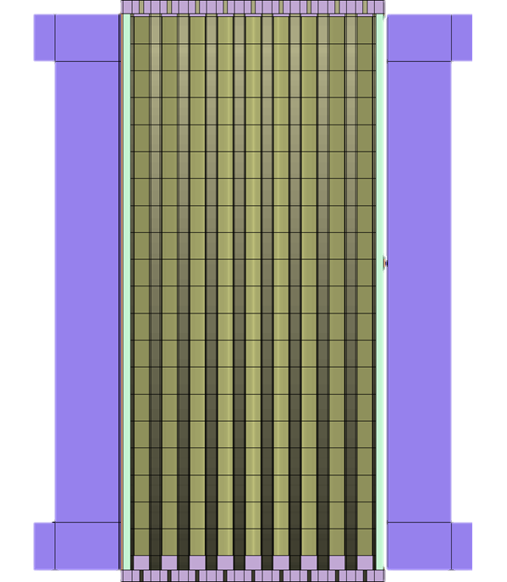

**Figure 2‑2:** Axial view of S8ER core with applied density and temperature fields.

## ‘snapReactors’ to ‘SIMBA’ Input File Generation

The benefits of having the package on the python platform will also be demonstrated by highlighting the ease of use of the software and easy integration with other python libraries such as ‘serpentTools’, a rising in popularity post processing tool for Serpent applications [4].The snapReactors package offers both an input file and memory-based approach. For users with limited python experience the input file-based approach is more convenient and significantly reduces the command count.

The workflow is split into three stages where the input data will be loaded into the python environment with snapReactors, the data will be used to create a serpent model with SIMBA, and the data will be post processed using serpentTools. First the input file data is read in using the reactor state reader. A snapshot of the input file is in Figure 2‑3, where the data is organized hierarchically with reference, units, uncertainty, and descriptions can be given.

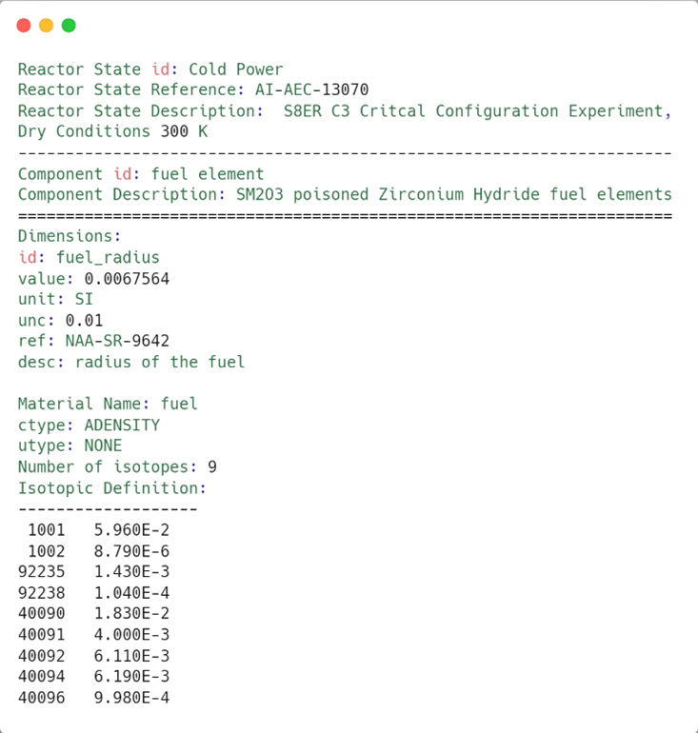

**Figure 2‑3**: Snapshot of input file for S8ER component and dimension specifications.

The data is neatly organized into pythonic dictionaries where the user can simply access objects by their name. The component objects are accessed from the cold power reactorState object and are saved to be used in the following SIMBA template.

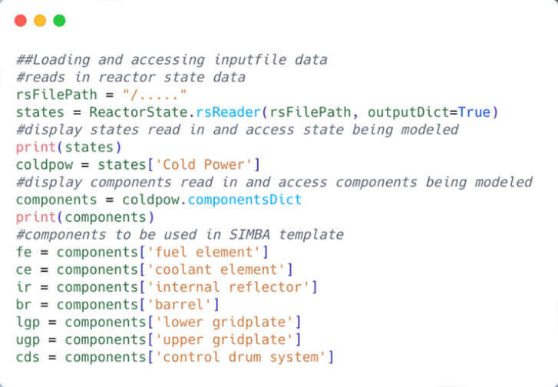

**Figure 2‑4**: Snapshot of S8ER data parsing by component

The SIMBA template is a configured model of the SNAP 8 Experimental Reactor. The template is made using builder functions from SIMBA to automate the creation of the serpent model from input data. The template takes in data from the cold power reactor state object and exports it into serpent format. The script generates a material, geometry, and main file each with the corresponding model data and parameters extracted from the database including descriptions and references listed at the top of each file. The resulting serpent models are displayed in Figure 5‑1 and Figure 5‑2.

# Experiments & Physical Data

## General Overview of Experiment

* Dates: May 19, 1963 – April 15, 1965 [4]
* Location: North American Aviation Field Test Area, SNAP Critical Facility Building 373 [5]
* Purpose: Demonstrate microreactor operation and determine reactor performance characteristics over various power levels and core temperatures up to and including design conditions.
* Design Objectives [4]:
  + Power output up to 600 kWth
  + 10,000-hour operational lifetime
  + 1300 °F (~705 °C) NaK outlet temperature
  + 350 lb (~159 kg) reactor weight
* Varied parameters over all experiments [4] [5]:
  + Reflector Shim geometry and ordering
  + Fuel and dummy pin loading schemes
  + Reflector Drum orientation
  + Varied Hydrogen and U235 densities in fuel pin
  + Unique control mechanisms
    - Burnable poison composition
    - Boronated rod in assembly
    - Poison Spline
  + Internal Reflector loading
  + Coolant flow rate
  + Coolant Temperature
  + Operational Time
* Over 40 experiments were evaluated throughout the lifetime of the S8ER.

Section 3 will focus on the dry critical experiments done for the S8ER as that has been the focus of the work done thus far.

## Experiment Geometry and Measurement Procedures

The S8ER was an epithermal microreactor utilizing reflector control elements with highly enriched Uranium-Zirconium Hydride (UZrH) fuel in a triangular fuel lattice within the core. An assembly view of the reactor and sectional view of a fuel element are shown below in Figure 3‑1. It should be noted that dimensions provided in the sectional view of the fuel element are nominal and less precise than tabulated values in reference.

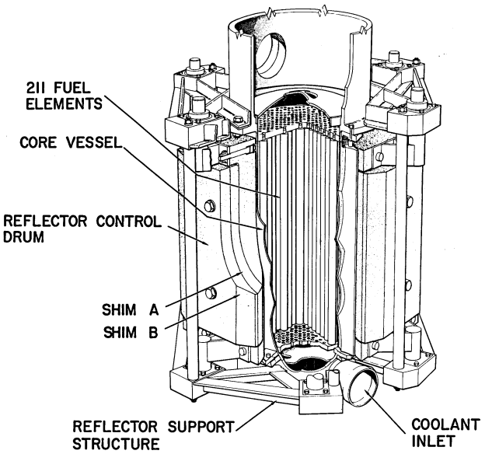

**Figure 3‑1**: Assembly view of S8ER core and fuel design with some components outlined [5].

From Figure 3‑1 we note that the core vessel contains 211 fuel elements, has coolant flowing from the bottom of the core region through the top, and is radially surrounded by reflector material. Although not clearly shown, there are stationary Beryllium reflectors that are seated between the control drums and the core vessel. Figure 3‑2 provides axial and radial views of the S8ER with more labeling for components that are not clearly visible in Figure 3‑1.

**Figure 3‑2**: Axial and radial view of S8ER core with labeled components [5].

In Figure 3‑2 we note that the reflector shim plates are attachments that are fastened within the reflector control drums. While not showcased in either of the figures above, there are eighteen internal reflector inserts that are located within the core vessel adjacent to the fuel elements, which are composed of Beryllium Oxide. Components integral to dry experiment neutronics simulations along with their dimensions as provided by Ref. [5] are presented in Table 3‑1. Note that the components and their material data are shown in Table 3‑2.

**Table 3‑1**: S8ER component dimensioning and geometry in inches and cm.

|  |  |  |  |
| --- | --- | --- | --- |
| **Component** | **Dimension Type** | **Dimension [in]** | **Dimension [cm]** |
| Reactor Vessel | Outside Diameter | 9.3520 | 23.75408 |
| Core Region Thickness | 0.0626 | 0.15900 |
| Upper Head Region Thickness | 0.2500 | 0.63500 |
| Lower Head Region Thickness | 0.1250 | 0.31750 |
| Upper Head Height | 3.5000 | 8.89000 |
| Lower Head Height | 4.0000 | 10.16000 |
| Overall Height | 24.0000 | 60.96000 |
| Reflecting Drums | Length | 14.5000 | 36.83000 |
| Radius of Curvature | 4.6800 | 11.88720 |
| Effective Thickness (No Shims) | 2.3400 | 5.94360 |
| Reflector-to-Core Radial Gap | 0.0818 | 0.20777 |
| Reflecting Shims | Length | 12.0000 | 30.48000 |
| Shim A Thickness | 0.7500 | 1.90500 |
| Shim B Thickness | 0.8800 | 2.23520 |
| Shim C Thickness | 1.1300 | 2.87020 |
| UZrH Fuel Elements | Length (no grid pins) | 14.4690 | 36.75126 |
| Outside Diameter | 0.5620 | 1.42748 |
| Fuel Rods | Length | 14.0000 | 35.56000 |
| Outside Diameter | 0.5320 | 1.35128 |
| Fuel-to-Clad Radial Gap* | 0.0016 | 0.00406 |
| Fuel-to-Clad Axial Gap* | 0.0240 | 0.06096 |
| Ceramic Coating Thickness* | 0.0022 | 0.00559 |
| Cladding Thickness* | 0.0104 | 0.02642 |
| Upper End Cap Thickness | 0.0800 | 0.20320 |
| Lower End Cap Thickness | 0.3700 | 0.93980 |
| Core | Length | 14.0000 | 35.56000 |
| Triangular Lattice Pitch | 0.5700 | 1.44780 |
| Diameter Across Corners | 9.2500 | 23.49500 |
| Diameter Across Flats | 9.0000 | 22.86000 |
| Equivalent Core Diameter | 8.6940 | 22.08276 |
| Upper Grid | Thickness | 0.3440 | 0.87376 |
| Lower Grid | Thickness | 0.3130 | 0.79502 |
| Coolant Flow Baffle | Thickness | 0.0625 | 0.15875 |
| Diameter | 9.1875 | 23.33625 |

Dimensions for the flange, drive shaft, reflector & control drum support structure, NaK coolant inlet, and control drum bushing were not provided as they were reported as less significant to neutronic analysis [5]. Quantities labeled with an asterisk* are noted as being nominal mean values across all 211 fuel elements. Additionally, there are no uncertainties listed or associated with the above dimensions from source references. Dimensions’ uncertainties will be ascertained through collaborative efforts with BWXT and will be a primary focus moving forward.

Experimental techniques for reactivity adjustments were done through four primary methods [5]:

* Changing fuel loading.
* Control drum & shim configurations.
* Control drum positioning.
* Introducing and removing elements and material of various moderating, capturing and fissile capabilities.

The array of fuel was partitioned into nine rings. Neutron reflector drums were rotated up to 105° out from the IN position to insert negative reactivity. The fuel element array along with the drum control scheme are shown below in Figure 3‑3.

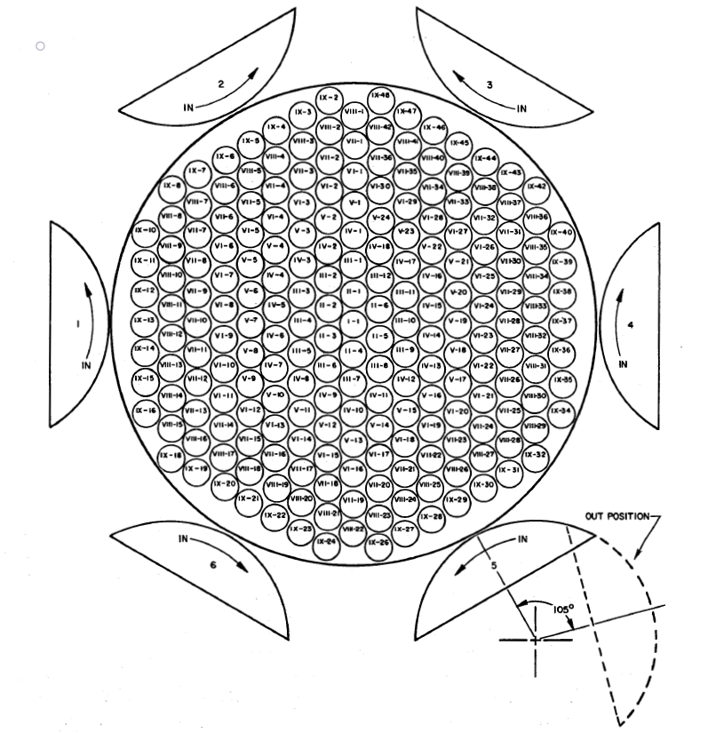

**Figure 3‑3**: Fuel element array and control drum positioning [5].

In every experiment the reactor operator was physically limited to insert less than 50¢ of excess reactivity to prevent prompt criticality behavior. This was done by locking a drum in the OUT position and restricting the rotation of at least one drum. Excess reactivity insertions were measured in terms of the stable reactor period, which was obtained from semilog plots or least-square fitting of the counts vs time from at least two instruments; detection instruments were never specified. The reactor period was converted to reactivity using the six-group Inhour equation, with an assumed effective delayed neutron fraction of 0.0077 [5].

Subcritical reactivity insertions were measured in terms of inverse multiplication plots. Incremental fuel additions were limited to twelve fuel elements or no more than half of the extrapolated fuel elements necessary for criticality, whichever was smaller. When criticality was extrapolated to be within two fuel elements, one fuel element was added at each step. Similarly, drum reactivity insertions near critical were limited by inverse multiplication extrapolations to produce a stable period of at least 20 seconds. Alternative methods of subcritical reactivity measurements were deemed unsuccessful. A Pu-Be source of 2E+6 neutrons/second was utilized for subcritical monitoring [5].

### Critical Configuration

The initial loading approach to criticality began with 211 dummy lucite rods with six internal reflectors lining the core wall. Lucite is an acrylic plastic with the same geometry as a fuel-moderator element, thus the lucite rods were replaced with loaded fuel-moderator elements as reactivity loading was increased [5]. The loading always began from one side of the core which resulted in crescent-shaped asymmetrical loading patterns. The first configuration, C-1, is explicitly outlined in documentation and shown below in Figure 3-4.

**Figure 3‑4**: C-1 lucite and fuel loading pattern [5].

## Materials

Material compositions of components outlined in Table 3‑1 are shown below in Table 3‑2, along with their densities and mass loadings when specified.

**Table 3‑2**: S8ER material composition and information.

|  |  |  |  |  |
| --- | --- | --- | --- | --- |
| **Component** | **Material** [5] | **Density [g/cm3]** | **Mass Loading** | **Misc. Comments** |
| Reactor Vessel | SS316 | 7.87 [6] | - | - |
| Reflecting Drum | Be | 1.84 | - | - |
| Reflector Shims | Be | 1.84 | - | - |
| Stationary Reflectors | Be | 1.84 [5] | - | - |
| Internal Reflectors | BeO | 3.02 [5] | - | - |
| Hastelloy-N | 8.86 [7] | - | - |
| Fuel Rods | UZrH | 6.06 [5] | 6.44 kg [5] | In Ref. [4] loading is listed as 6.56 kg |
| He | 1.574E-5 [8] | - | - |
| AI8763D | 2.8 [9] | - | - |
| Sm2O3 | 8.35 [5] | 8.51 [5] | Linear density listed as 2.88 mg/in |
| Hastelloy-N | 8.86 | - | - |
| Dummy Pins | Lucite | 1.19 [10] | - | - |
| Upper Grid | SS316 | 7.95 | - | - |
| Lower Grid | Hastelloy-C | 8.89 [7] | - | - |

Note that no uncertainties are present as they were not indicated in SNAP documentation. These will be determined independently.

## Temperatures

All measurements were obtained with the assembly at constant room temperature which was reported to be approximately 75°F (~24°C) [5].

# Benchmark Models Insufficiency Report

Dimensions indicated in references are not always obvious, and often left without description or inconsistent between different reports. Dimensions listed in Ref. [5] were chosen when inconsistencies appeared, although other reports were utilized when otherwise not provided. Furthermore, some figures are ambiguous and are not dimensioned as seen in Figure 3‑1 and Figure 3‑2. To this end, in the absence of data best judgement was used and when possible guided by illustrations provided in references.

Material loading specifications were inconsistent between references, such as the total burnable poison loading and the uranium loading. Values were defaulted to match those seen in Ref. [5] to conform to conditions seen during the dry critical experiments. Future work will attempt to quantify the impact of different loading specifications on reactor behavior by performing sensitivity analysis.

## Verification Studies

Verification studies were performed to confirm modeled masses and geometry are consistent with reported values. Verification work was performed for the fuel element geometry and composition, active core modeling and composition, and with reflector modeling and geometry in that order.

### Fuel Element Modeling & Composition Verification

This section will outline the process by which the fuel composition was verified and utilizing the table found in Ref. [5] as a comparison for values used in the Serpent model. The fuel element follows the traditional fuel rod layout where a mix of Hydrided Uranium-Zircalloy (UZr-H 10% wt. hydrided) fuel is encased in a ceramic coating (AI-8763D) serving as a hydrogen diffusion barrier, containing a layer of Samarium Oxide (Sm2O3) serving as a burnable poison [9]. The AI-8763D ceramic is a unique ceramic composite developed specifically for the S8ER to prevent at least 5% total hydrogen loss in the fuel after 10,000 hours of total operation. This material was developed in response to experimentation revealing metal cladding by itself was not sufficient to prevent a less than 5% hydrogen loss out the core [9]. A helium gap at 0.1 atm pressure to allow for expansion of the fuel is present between the ceramic coating and a casing of Hastelloy-N serving as the fuel cladding. The data to construct the fuel model is taken directly from Figure 8 in Ref. [3]. Where the following assumptions and interpretations are made for the modeling of the fuel composition:

- The UZr-H fuel is well-mixed such that it can be modeled as a homogenous mixture.

- The outside diameter is taken as the fuel-moderator mix outer diameter.

- The length is taken as the active fuel length of the fuel-moderator mix.

Using the parameters and assumptions a comparison is made and is used to verify the composition for the fuel-moderator mix yielding the results presented in ***.*** Overall, the results for the modeling of the fuel-moderator mix are in good agreement with the experimental values. Values for the isotopic compositions of the fuel-moderator mix and calculations are shown in Appendix A.

**Table 4‑1**: Fuel-moderating material composition verification, * indicates averaged values over all manufactured components.

|  |  |  |
| --- | --- | --- |
| **Parameter [units]** | **Reported Value** | **Modeled Value** |
| Material | Enriched U-Zr Alloy, Zr-Hydrided | Enriched U-Zr Alloy, Zr-Hydrided |
| Outside Diameter [in] | 0.532 | 0.532 |
| Axial Length [in] | 14 | 14 |
| Total Weight [g] | 309.653* | 309.023 |
| U Weight [g] | 30.4* | 30.4 |
| U-235 Enrichment [wt%] | 93.15* | 93.14 |
| NH [atoms/barn-cm] | 5.96E-02* | 5.96E-02 |
| U [wt%] | 9.82 | 9.84 |
| Zr [wt%] | 88.53 | 88.52 |
| H [wt%] | 1.65 | 1.64 |
| H/Zr Atom Ratio [-] | 1.7 | 1.67 |
| Fuel Rod Density [g/cm^3] | 6.06 | 6.06 |

With the verification of the fuel-moderator mix, similarly, all parameters used to model the fuel element are extracted from Table 1 in Ref. [5], a portion of which is shown below in .

**Table 4‑2**: Fuel element parameters, note that * indicates averaged values over all manufactured components.

|  |  |  |
| --- | --- | --- |
| **Parameter [units]** | **Reported Value** | **Modeled Value** |
| ***Fuel rods*** | | |
| Material | Enriched U-Zr Alloy,  Zr-Hydrided | Enriched U-Zr Alloy,  Zr-Hydrided |
| Outer diameter [in] | 0.532 | 0.532 |
| ***Ceramic Coating*** | | |
| Material | AI-8763D | AI-8763D |
| Thickness [in] | 0.0022* | 0.0022 |
| Sm2O3 loading [mg/in] | 2.88 | 2.88 |
| ***Fuel-to-Clad Gaps*** | | |
| Material | Helium | Helium |
| Thickness [in] | 0.0016* | 0.0016 |
| ***Cladding*** | | |
| Material | Hastelloy-N | Hastelloy-N |
| Outer diameter [in] | 0.562* | 0.562 |

A unit-cell of the fuel element is shown below in Figure 4‑1 dimensioned in cm. A choice was made to homogenize the burnable poison within the ceramic coating, as the layer of burnable poison thickness is not provided, and homogenization allows for better poison loading estimation. The mass fractions for the homogenized ceramic coating are calculated to preserve the overall burnable poison loading detailed in Ref. [1] of 8.51g for beginning of life operation (BOL), calculations are detailed in Appendix A. In other models for the SNAP10A and SNAP2 reactors, the helium gap was homogenized with the ceramic coating and burnable poison, however helium at such low density is practically transparent and has no appreciable effect on neutronic behavior [2]. The following assumptions and interpretations are made:

* Ceramic coating modeling is homogenized with burnable poison.
* Material order is interpreted as fuel-moderator mix, ceramic coating with poison, gap, and cladding.
* The experimental setup does not suggest any pressurized systems, thus ambient air surround fuel elements [1].
* Indexing pins (shown in Figure 4‑1) are homogenized within grid plates.
* Axial helium gap is neglected.

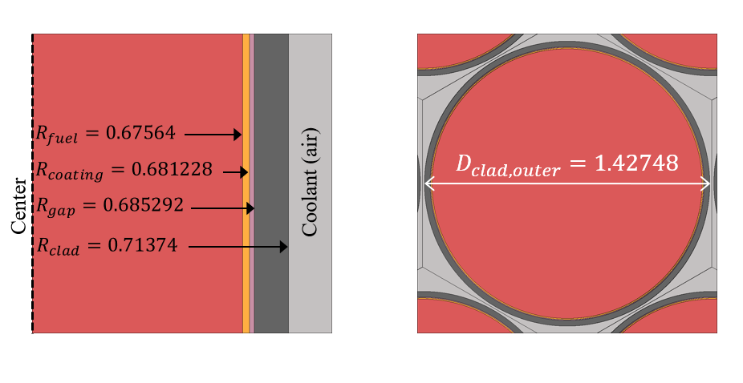

(a) xz view (b) xy view

**Figure 4‑1**: Unit cell of the fuel element dimensioned in cm

### Active Core Modeling & Composition Verification

This section will similarly continue the process of verification for the active core. The active core is considered as the region containing the fuel elements and the void region, which will contain NaK, excluding the internal reflectors spanning only the active fuel region. A model isolating only the active core is shown below in , where the following assumptions and interpretations are made:

* Active core regions cover radially inward from the internal reflector and axially covers the active fuel length (no endcaps).
* Diameter across flats refers to equivalent hexagon apothem.
* Diameter across corners refers to equivalent cylinder diameter.
  + Note that the equivalent core diameter noted in Table 1 of Ref. [5] is not used as that dimension corresponds to a homogenized active core region.

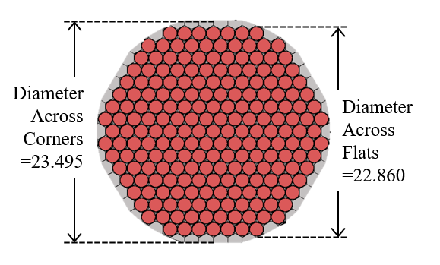

**Figure 4‑2**: S8ER core mock-up comparison with experimental setup dimensioned in cm [5].

The results for the model using parameters extracted from Ref. [1] and assumptions above are shown below in . Overall, the results for the modeling of the active core are in good agreement with the experimental values. There is slight discrepancy between modeled and experimental Hydrogen to U-235 atom ratio, which stem from slight overprediction in Uranium assay modeled in the fuel coupled with slight underprediction in total fuel element weight. Values for the isotopic compositions of the active core materials and calculations are shown in Appendix A

**Table 4‑3**: Active core modeling parameter verification

|  |  |  |
| --- | --- | --- |
| **Parameter [units]** | **Reported Value** | **Modeled Value** |
| Lattice Spacing [in] | 0.57 | 0.57 |
| Diameter Across Corners [in] | 9.25 | 9.25 |
| Diameter Across Flats [in] | 9.0 | 9.0 |
| Equivalent Core Diameter [in] | 8.694 | - |
| Core Length [in] | 14.0 | 14.0 |
| Total Uranium [kg] | 6.44 | 6.41 |
| Total Sm2O3 [g] | 8.51 | 8.51 |
| H/U-235 Atom Ratio | 42.4 | 41.68 |
| **Volume Fraction**  Fuel Rod  Fuel Void  Cladding  Ceramic  Void – NaK | 0.790  0.01  0.067  0.013  0.120 | 0.790  0.01  0.069  0.013  0.118 |

### Reflector Modeling & Geometry Verification

This section will detail the derivation and verification of reflector component geometric parameters. Control shims are reflecting components made of Be metal that are inserted within the Be metal control drum to increase total reflecting mass and mitigate neutron leakage from the core. In total, there are up to three shims that can be inserted in various combinations for each reflecting drum, labelled A, B, and C. Auxiliary SNAP documentation [11] suggests that the A and B shim are roughly rectangular prisms while the C shim is composed of two discrete trapezoidal prisms, though this is not confirmed in Ref. [5]. Shim configurations refer to the shim label and designate the order in which they are mounted in a control drum. As an example, an A-B configuration would have the A shim as the innermost shim, followed by the B shim. The labelled drum, A shim, B shim, and C shim (an A-B-C configuration) from a quarterly report [11] showcase changes to geometry and dimensioning for shim components in Figure 5; inner shim, new middle shim, and outer shim refer to the A, B and C shims respectively.

**Figure 4‑3**: Schematic of drum, A shim (inner), B shim (new middle) and C shim (outer)

The characteristics of the S8ER made it a high leakage system with high reflectivity; hence, the system was extremely sensitive to reflector thickness. To mitigate this sensitivity, experimenters inserted additional Be reflecting components named stationary reflectors which were six reflecting pieces that filled space between the barrel and control drums [5]. As a result, an emphasis is placed on preserving key parameters among the criticality configuration models such as the effective reflector thickness. Parameters for the control drums are taken from Table 1 in Ref. [5], which is replicated in Table 4‑4 for convenience.

**Table 4‑4**: External reflector parameters

|  |  |
| --- | --- |
| **Parameter [units]** | **Reported Value** |
| Material | Beryllium |
| Number of Drums | 6 |
| Number of Stationary Pieces | 6 |
| Length [in] | 14.5 |
| Density [g/cm3] | 1.84 |
| Drum Radius of Curvature [in] | 4.68 |
| Core vessel – reflector radial gap [in] | 0.0818 |
| **Shim Thickness [in]**  A  B  C | 0.750  0.880  1.13 |
| **Effective Reflector Thickness [in]**  No Shims  A Shims  A+B Shims  A+B+C Shims | 2.34  3.08  3.78  4.73 |

There is a distinction between the effective reflector thickness and shim thickness. Although no clear methodology for the calculation of the effective reflector thickness is explicitly provided, computational analyses performed for the SNAP 10A reactor showcase the SNAP program’s approach for building a computational model [12]. This approach is visualized in Figure 4‑4 where equivalent annular regions were constructed for each respective region [12].

**Figure 4‑4**: Computational model for SNAP 10A analyses [12].

All SNAP systems have nearly identical material compositions, control mechanisms and high-frequency iterations in their development process, thus it is assumed that a similar approach was done for the computational modeling of the S8ER. To this end, the effective reflector thickness is interpreted to be an equivalent annular thickness.

With this approach, an equivalent annular volume is calculated to preserve the mass of reflector material. Parameters are extracted directly from Table 1 in Ref. [5] where additional extrapolated calculations are shown here.

${R_{drum}}_{inner}={R_{barrel}}_{outer}+t_{vessel-gap}$ (4‑1)

As mentioned above, the effective reflector thickness is determined to be an equivalent annular thickness ${\tilde{t}}_{eff}$.

${\tilde{R}}_{drum_{outer}}={R_{drum}}_{inner}+{\tilde{t}}_{drum_{eff}}$ (4‑2)

${\tilde{R}}_{shim{-a}_{outer}}={\tilde{R}}_{drum_{outer}}+{\tilde{t}}_{{shim-a}_{eff}}$ (4‑3)

${\tilde{R}}_{shim{-b}_{outer}}={\tilde{R}}_{shim{-a}_{outer}}+{\tilde{t}}_{{shim-b}_{eff}}$ (4‑4)

${\tilde{R}}_{shim{-c}_{outer}}={\tilde{R}}_{shim{-b}_{outer}}+{\tilde{t}}_{{shim-c}_{eff}}$ (4‑5)

The effective annular area is calculated for the drum and shim layers.

${\tilde{A}}_{{drum}_{annular}}=π{\left({\tilde{R}}_{drum_{outer}}- {R_{drum}}_{inner}\right)}^{2}$ (4‑6)

${\tilde{A}}_{{shim-a}_{annular}}=π{\left({\tilde{R}}_{{shim-a}_{outer}}- {\tilde{R}}_{drum_{outer}}\right)}^{2}$ (4‑7)

${\tilde{A}}_{{shim-b}_{annular}}=π{\left({\tilde{R}}_{{shim-b}_{outer}}- {\tilde{R}}_{{shim-a}_{outer}}\right)}^{2}$ (4‑8)

${\tilde{A}}_{{shim-c}_{annular}}=π{\left({\tilde{R}}_{{shim-c}_{outer}}- {\tilde{R}}_{{shim-b}_{outer}}\right)}^{2}$ (4‑9)

The effective total area including the active core is calculated.

${\tilde{A}}_{drum_{total}}=π{R_{drum}^{2}}_{inner}+ {\tilde{A}}_{{drum}_{annular}}$ (4‑10)

The effective total area is converted to an effective total hexagonal area as it most accurately depicts control shim geometry as seen in Figure 4‑4. The effective hexagonal apothem $\tilde{a}$ is calculated from the area.

${\tilde{s}}_{drum}=\sqrt{\frac{2{\tilde{A}}_{drum_{total}}}{3\sqrt{3}}}$ (4‑11)

(4‑12)

**Figure 4‑5**: Shim annular to hexagonal geometry.

The rectangular shim slab widths are calculated to preserve the respective equivalent annular areas for each shim layer. The slab length is calculated using the chord length of the drum apothem and drum radius of curvature.

$c_{drum}= {R_{drum}}_{inner}+R_{curvature}$ (4‑13)

(4‑14)

(‑)

(4‑16)

**Table 4‑5**: Control drum and shim parameters I.

|  |  |
| --- | --- |
| **Parameter [cm]** | **Value** |
| Outer Barrel Radius | 11.877 |
| Vessel - Drum Gap Thickness | 0.208 |
| Drum Inner Radius | 12.313 |
| Drum Radius of Curvature | 11.887 |
| Drum Side Length Equivalent Hex | 20.076 |
| Drum Apothem Length Equivalent Hex | 17.472 |

**Table 4‑6**: Control drum and shim parameters II.

|  |  |  |  |  |
| --- | --- | --- | --- | --- |
| **Layer** | Effective  Reflector  Thickness [cm] | Effective Reflector  Outer Radius [cm] | Effective Annular  Area [cm2] | Modeled  Shim Slab  Width [cm] |
| Drum | 5.943 | 18.258 | 570.824 | 12.516 |
| Shim A | 1.879 | 20.137 | 226.709 | 4.819 |
| Shim B | 1.778 | 21.915 | 234.889 | 4.993 |
| Shim C | 2.413 | 24.328 | 350.547 | 7.452 |

# Benchmark-model Specifications

## Model Simplifications

Computational modeling for neutronics analysis was done in Serpent utilizing Idaho National Laboratory’s High Performance Computing resources [1]. The dry critical experiments were modeled with the initial primary focus on the critical loading experiment. The S8ER assembly was loaded with four unique configurations that varied fuel-moderator elements, reflector shim installment, and drum rotation to the OUT position. In modeling these experiments, some simplifications were made:

* Coolant baffle plate was not modeled.
* Coolant inlet and outlet regions were not modeled.
* Supporting structures for reflecting element were not modeled.
* Fasteners for neutron reflector shim was not modeled.
* Thermocouples were not modeled.
* Internal reflector tie rod pins were not modeled.
* Internal reflectors were modeled based on reference volume fractions with suitable void material.
* Burnable poison was homogenized into AI8763D ceramic.

### Unmodeled Components

While including unmodeled components would be necessary to maximize accuracy, their contributions to validating reactivity is expected to be relatively small while substantially increasing the complexity of the model. Furthermore, any small perturbations to reactivity they might induce are expected to be within uncertainty. To verify this is the case along with corresponding uncertainties, future work looks to homogenize material with appropriate volume fractions when possible, such as the case with the fasteners for the reflecting shims. Components not embedded within the active core structure, such as the supporting structure, will be coarsely modeled to evaluate their reactivity contributions.

## Benchmark-model Geometry

In Figure 5‑1, radial geometry of the core with control elements are shown dimensioned in cm

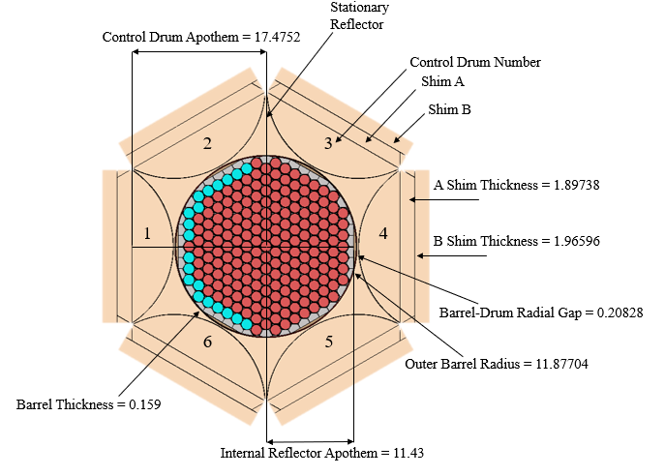

**Figure 5‑1**: S8ER core (xy view), reflector drum and shims dimensioned in cm.

Axial portions were then added to the Serpent model which is shown in Figure 5‑2 dimensioned in cm.

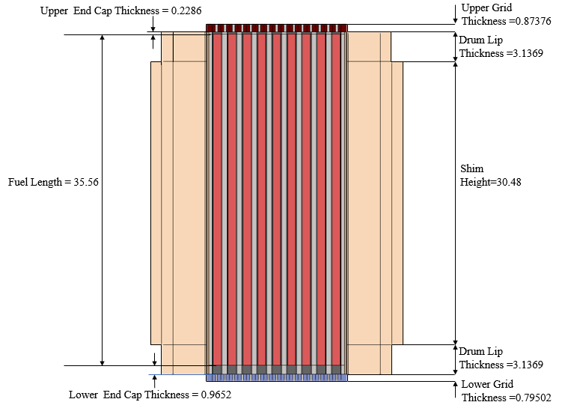

**Figure 5‑2**: S8ER core and reflector (xz view) dimensioned in cm.

The material that is present between the fuel elements seen in Figure 5‑3 above is air, which is assumed present in the core during the dry critical experiments. All dimensions shown in the figures above correspond to what is exactly noted in Table 3‑1, Table 4‑3, Table 4‑5, and Table 4‑6.

## Materials and Benchmark Model

The atomic densities in atoms/(b-cm) that were utilized for this work are tabulated below in Table 5-1. The nuclides are identified according to the number of protons (ZZ) and nucleons (protons + neutrons, *i.e.*, AAA).

**Table 5‑1**: Isotopic material composition for all materials utilized in S8ER modeling [1].

|  |  |  |
| --- | --- | --- |
| **Material** | **Nuclide [ZZAAA]** | **Density [atoms/b-cm]** |
| Uranium Zirconium Hydride | 1001 | 5.96000E-02 |
| 1002 | 8.79000E-06 |
| 40090 | 1.83000E-02 |
| 40091 | 4.00000E-03 |
| 40092 | 6.11000E-03 |
| 40094 | 6.19000E-03 |
| 40096 | 9.98000E-04 |
| 92235 | 1.43000E-03 |
| 92238 | 1.04000E-04 |
| Hastelloy-C [7] | 14028 | 1.41333E-04 |
| 14029 | 6.86588E-06 |
| 14030 | 4.33981E-06 |
| 23051 | 3.67831E-04 |
| 24050 | 7.45215E-04 |
| 24052 | 1.38189E-02 |
| 24053 | 1.53735E-03 |
| 24054 | 3.75594E-04 |
| 25055 | 9.74540E-04 |
| 26054 | 2.90082E-04 |
| 26056 | 4.39125E-03 |
| 26057 | 9.96308E-05 |
| 26058 | 1.30305E-05 |
| 27059 | 2.27119E-03 |
| 28058 | 3.43243E-02 |
| 28060 | 1.27815E-02 |
| 28061 | 5.46477E-04 |
| 28062 | 1.71437E-03 |
| 28064 | 4.22939E-04 |
| 29063 | 2.94158E-04 |
| 29065 | 1.27194E-04 |
| 42092 | 1.36538E-03 |
| 42094 | 8.37243E-04 |
| 42095 | 1.43271E-03 |
| 42096 | 1.48925E-03 |
| 42097 | 8.47029E-04 |
| 42098 | 2.12544E-03 |
| 42100 | 8.35474E-04 |
| 6000 | 4.46120E-05 |
| 74182 | 3.11911E-04 |
| 74183 | 1.67509E-04 |
| 74184 | 3.56713E-04 |
| 74186 | 3.27418E-04 |
| Hastelloy-N [7] | 13027 | 4.95122E-04 |
| 14028 | 1.76327E-03 |
| 14029 | 8.56588E-05 |
| 14030 | 5.41435E-05 |
| 22046 | 2.39840E-05 |
| 22047 | 2.11690E-05 |
| 22048 | 2.05397E-04 |
| 22049 | 1.47653E-05 |
| 22050 | 1.38554E-05 |
| 23051 | 5.24465E-04 |
| 24050 | 3.25406E-04 |
| 24052 | 6.03421E-03 |
| 24053 | 6.71298E-04 |
| 24054 | 1.64007E-04 |
| 25055 | 7.78136E-04 |
| 26054 | 2.31621E-04 |
| 26056 | 3.50626E-03 |
| 26057 | 7.95517E-05 |
| 26058 | 1.04044E-05 |
| 27059 | 1.81346E-04 |
| 28058 | 4.33818E-02 |
| 28060 | 1.61542E-02 |
| 28061 | 6.90684E-04 |
| 28062 | 2.16677E-03 |
| 28064 | 5.34546E-04 |
| 29063 | 1.17437E-04 |
| 29065 | 5.07801E-05 |
| 42092 | 1.36276E-03 |
| 42094 | 8.35637E-04 |
| 42095 | 1.42996E-03 |
| 42096 | 1.48639E-03 |
| 42097 | 8.45404E-04 |
| 42098 | 2.12137E-03 |
| 42100 | 8.33871E-04 |
| 6000 | 2.67159E-04 |
| 74182 | 3.89141E-05 |
| 74183 | 2.08985E-05 |
| 74184 | 4.45036E-05 |
| 74186 | 4.08488E-05 |
| Stainless Steel 316 [6] | 6000 | 3.19301E-04 |
| 7014 | 3.40766E-04 |
| 7015 | 1.21187E-06 |
| 14028 | 1.18542E-03 |
| 14029 | 5.75871E-05 |
| 14030 | 3.63998E-05 |
| 15031 | 3.47948E-05 |
| 16032 | 4.28282E-05 |
| 16033 | 3.19029E-07 |
| 16034 | 1.67736E-06 |
| 16036 | 5.19387E-09 |
| 24050 | 7.08383E-04 |
| 24052 | 1.31360E-02 |
| 24053 | 1.46136E-03 |
| 24054 | 3.57030E-04 |
| 25055 | 1.74376E-03 |
| 26054 | 3.40069E-03 |
| 26056 | 5.14793E-02 |
| 26057 | 1.16799E-03 |
| 26058 | 1.52758E-04 |
| 28058 | 6.75407E-03 |
| 28060 | 2.51504E-03 |
| 28061 | 1.07532E-04 |
| 28062 | 3.37341E-04 |
| 28064 | 8.32229E-05 |
| 42092 | 1.90867E-04 |
| 42094 | 1.17039E-04 |
| 42095 | 2.00280E-04 |
| 42096 | 2.08183E-04 |
| 42097 | 1.18407E-04 |
| 42098 | 2.97117E-04 |
| 42100 | 1.16791E-04 |
| Beryllium | 4009 | 1.22951E-1 |
| Beryllium Oxide | 4009 | 7.27124E-2 |
| 8016 | 7.27330E-2 |
| Samarium Oxide | 8016 | 4.32706E-02 |
|  | 62144 | 9.25038E-04 |
| 62147 | 4.42440E-03 |
| 62148 | 3.29514E-03 |
| 62149 | 4.02422E-03 |
| 62150 | 2.13464E-03 |
| 62152 | 7.63533E-03 |
| 62154 | 6.40913E-03 |
| AI-8763D [9] | 3006 | 7.18410E-05 |
| 3007 | 1.20834E-03 |
| 8016 | 3.81971E-02 |
| 12024 | 8.73652E-05 |
| 12025 | 1.06640E-05 |
| 12026 | 1.13387E-05 |
| 14028 | 1.23620E-02 |
| 14029 | 6.00540E-04 |
| 14030 | 3.79592E-04 |
| 20040 | 4.46292E-04 |
| 20042 | 2.83692E-06 |
| 20043 | 5.78159E-07 |
| 20044 | 8.73102E-06 |
| 20046 | 1.60141E-08 |
| 20048 | 7.17452E-07 |
| 22046 | 1.80902E-04 |
| 22047 | 1.59669E-04 |
| 22048 | 1.54923E-03 |
| 22049 | 1.11369E-04 |
| 22050 | 1.04506E-04 |
| 25055 | 2.18593E-04 |
| 38084 | 1.02256E-06 |
| 38086 | 1.75861E-05 |
| 38087 | 1.23414E-05 |
| 38088 | 1.43944E-04 |
| 40090 | 3.56045E-04 |
| 40091 | 7.67899E-05 |
| 40092 | 1.16099E-04 |
| 40094 | 1.15148E-04 |
| 40096 | 1.81637E-05 |
| 56130 | 4.06703E-06 |
| 56132 | 3.64126E-06 |
| 56134 | 8.68031E-05 |
| 56135 | 2.34621E-04 |
| 56136 | 2.77428E-04 |
| 56137 | 3.93978E-04 |
| 56138 | 2.49721E-03 |
| Helium | 2004 | 2.36813E-3 |
| Air [12] | 7014 | 3.96609E-05 |
| 7015 | 1.41307E-07 |
| 8016 | 1.06659E-05 |
| 8017 | 3.71891E-09 |
| 18036 | 5.48238E-09 |
| 18038 | 1.07776E-08 |
| 18040 | 2.23616E-07 |

The atomic density of the zirconium hydride was computed directly from the loading of uranium for the dry critical experiments [5].Fuel specifications and dimensions were provided, while the volume of the fuel rod was computed and a mass density was taken as the average uranium loading per rod over the rod’s volume. The weight enrichment value of 93.15% was used to obtain atomic densities. It should be noted that while the number density of hydrogen is provided in reference, it is a nominal value whose uncertainty is not provided thus it was deemed appropriate to determine this manually.

Other atomic densities are computed directly from Serpent as the model was provided with fractional mass densities [13]. References near material names indicate sources for elemental fractions, which were then used in conjunction with Ref. [13] to evaluate isotopic mass fractions. This conversion to atomic densities via Serpent is accurate so long as the user provides a total mass density of the material, which they were. Serpent does not provide uncertainties with these computations thus none are provided. Future work will look to determine these uncertainties utilizing Ref. [13].

## Expected Benchmark Values

Ultimately, the full range of dry experiments will be modelled. Here, a preliminary analysis is performed of four critical experiments, special fuel worths, and poison reactivity worths. Recall Figure 3‑4 showcases the fuel-moderator element loading method utilized for the C-1 configuration. The exact loading arrangement for subsequent configurations, namely C-2 and C-4 were not explicitly shown. It was decided that the positioning of the lucite pins to model the critical loading scheme for C-2 and C-4 should remain consistent observed asymmetric crescent-shaped loading as seen in Figure 3-4. The resulting loading schemes used in Serpent are shown below in Figure 5-4

The initial loading approach to critical in the experiments was begun with 211 dummy lucite rods with six internal reflectors lining the core wall. Lucite is an acrylic plastic with the same geometry as a fuel-moderator element, thus the lucite rods were replaced with loaded fuel-moderator elements as reactivity loading was increased. The loading always began from one side of the core which resulted in crescent-shaped asymmetrical loading patterns. The first configuration, C-1, is explicitly outlined in documentation and shown below in Figure 5‑4 [5].

(a) C-1 (b) C-2

(c) C-3 (d) C-4

**Figure 5‑3**: Critical configuration of the S8ER, showing fuel and reflector loading schemes.

The results of the modeled critical loading schemes will be detailed in Table 6-1 which presents expected reactivity at each configuration. Experimental uncertainties were not reported for this set of data [5]. This has not been refined further which is why the uncertainties are left unreported in Table 6‑1.

# Calculated Serpent Results

Results were computed utilizing Serpent 2.1.32 with ENDFB8 cross section libraries. [6]. For all models, the following bound scatterers were considered: Beryllium in BeO (Be-O), Oxygen in BeO (O-Be), Beryllium in Beryllium metal (Be-Bem), Hydrogen in Zirconium Hydride (H-Zr), Zirconium in Zirconium Hydride (Zr-H), and Hydrogen in the organic composite lucite (H-Luci).

### Critical Configurations

The critical loading schemes were run in Serpent for loading designations C-1 to C-4. A C-5 configuration reactivity was approximated in Ref. [5] but is not modeled as it was not measured

**Table 6‑1**: Critical core configuration reactivity results with ±1σ shown .

|  |  |  |  |  |
| --- | --- | --- | --- | --- |
| **Configuration** | **C-1** | **C-2** | **C-3** | **C-4** |
| Shims Installed | A-B | A | None | A-B |
| Drums Locked Out | None | None | None | No. 6 @ 105 Degrees |
| Number of Lucite Rods | 38 | 25 | 0 | 20 |
| Number of Fuel Elements | 178 | 186 | 211 | 191 |
| Experimental Excess Reactivity [pcm] | 75 | 111 | -216 | 72 |
| Modeled Excess Reactivity [pcm] | 55±5.3 | 150±5.2 | -240±5.2 | -210±5.3 |
| Reactivity Discrepancy [Δ pcm] | -20±5.3 | 40±5.2 | -25±5.2 | -280±5.3 |
| Reactivity Discrepancy [%] | -27 | 35 | -11 | -390 |

The first three configurations show good agreement with a discrepancy of less than or equal to 40 pcm. The C-4 configuration discrepancy underpredicts reactivity much more than the previous three, indicating an overestimation of leakage in the core. Referencing shim design from Figure 4‑3, the geometry of the A and B shims closely follow auxiliary reference. This suggests the model is effectively underestimating the total reflecting mass due to the exclusion of structural components, which become increasingly relevant as the control drum is rotated out.

### Special Fuel Worths

In experiment, fuel-moderating element compositions were varied to accurately capture variance in reactivity worths due to manufacturing tolerance limitations, along with quantifying reactivity worths at the center, half of the radius, and at the periphery of the core [3]. Thus, standard fuel-moderating elements were modeled according to designated hydrogen and uranium loadings at specific core positions. Their worths were then measured relative to substituted lucite and void worths at those positions. Recall the layout of rod positions were outlined in Figure 3‑3and Figure 3‑4.

The results of the Serpent solution along with measured results are recreated below in Table 8 with ±1σ reported. Overall, results show best agreement with cases that contain no Hydrogen content. It is important to note that fuel density and Zirconium assay content after Uranium and Hydrogen content adjustment are not reported and are thus the likely sources of discrepancy compared to Serpent results. The authors assumed the dimensioning of the fuel remained uniform and thus extracted fuel densities as fuel masses were reported. Zirconium content was adjusted based on reported Hydrogen densities and Uranium weight content.

**Table 6‑2**: Fuel reactivity worth values for various Hydrogen and Uranium loadings representative of manufacturing tolerances.

|  |  |  |  |  |  |  |  |  |
| --- | --- | --- | --- | --- | --- | --- | --- | --- |
| **Rod**  **No.** | **Fuel Weight [gm]** | **NH [1022]** | **Uranium [wt%]** | **Position\*** | **Experimental [pcm]** | | **Serpent [pcm]** | |
| **Relative to Lucite** | **Relative to Void** | **Relative to Lucite** | **Relative to Void** | **Lucite Discrepancy [**Δ **pcm]** | **Void Discrepancy [**Δ **pcm]** |
| Lucite | 70.64 | - | - | I-1 | 0 | 350 | 0 | 460±7.6 | 0 | 110±7.6 |
| E-181 | 309.3 | 5.97 | 9.7 | I-1 | 11 | 360 | 2.0±7.4 | 460±7.6 | 9.0±7.4 | 100±7.6 |
| E-672 | 311.5 | 6.27 | 9.95 | I-1 | 33 | 380 | 11±7.4 | 470±7.6 | 22±7.4 | 90±7.6 |
| E-669 | 317.3 | 5.97 | 10.11 | I-1 | 45 | 390 | 3.2±7.4 | 460±7.6 | 42±7.4 | 70±7.6 |
| E-671 | 293.9 | 6.15 | 9.32 | I-1 | 27 | 370 | 18±7.6 | 440±7.8 | 9.0±7.6 | 70±7.8 |
| E-661 | 278 | 0 | 9.54 | I-1 |  | 89 |  | 81±7.1 |  | 8.0±7.1 |
| E-660 | 278.3 | 0 | 9.78 | V-23 |  | 70 |  | 93±7.7 |  | 23±7.7 |
| E-661 | 278 | 0 | 9.54 | V-23 |  | 77 |  | 85±6.9 |  | 8.0±6.9 |
| E-661 | 278 | 0 | 9.54 | IX-45 |  | 110 |  | 120±7.6 |  | 9.0±7.7 |

### Burnable Poison Coating

The poison reactivity worth of the Sm2O3 ceramic coating was determined in experiment by measuring reactivity differences between the C-4 base case and when uncoated fuel elements are substituted. This was done with one and two fuel elements which was determined to have an average value of 2.3¢ (18 pcm) at the core center. This was mimicked in Serpent by modeling uncoated fuel elements and mimicking experimental procedure. The results are tabulated below in Table 6‑3.

**Table 6‑3**: Poison reactivity worth values for reported and modeled cases, ±1σ is shown.

|  |  |  |
| --- | --- | --- |
| **Position** | **I-1** | **I-1, I-2** |
| Experimental Poison Worth [pcm] | -19 | -33 |
| Modeled Poison Worth [pcm] | -27±5.9 | -49±6.7 |
| Reactivity Discrepancy [Δ pcm] | -8±5.9 | -16±6.7 |

Overall, results show good agreement though consistent underprediction for the poison reactivity worth values. This is due to unreported uncertainties regarding the poison loading in each fuel element as individual poison loadings for each element were not provided in Ref. [3]. In model, the poison loading in each fuel element was assumed to be uniform, though due to manufacturing tolerances at the time of experiment there will be deviations in poison loading.

# Preliminary 3D Griffin Results

Following calculated Serpent results, full 3D models of the S8ER core were developed in Griffin. In Figure 7‑1, the radial view, axial view, and unstructured mesh homogenization scheme are shown.

**Figure 7‑1**: S8ER 3D active core serpent models and unstructured mesh homogenization scheme

The continuous energy Monte Carlo code Serpent is used for the generation of homogenized few-group data and the finite element MOOSE based Discontinuous Finite Element Discrete Ordinates (DFEM-SN) neutronic solver in Griffin is used as the transport eigenvalue solver. All simulations were conducted on the SAWTOOTH INL HPC Cluster using Serpent 2.1.32 with the ENDF8 cross section library and the latest compiled version of Griffin/2023-06-30. The DFEM-SN Solver was used with a 12th order level-symmetric quadrature which produces an agreement of 78 pcm difference compared with the reference Serpent results, which is reported in Table 7‑1. For large problems this agreement is considered excellent with no optimization or correction procedures.

**Table 7‑1**: Serpent-Griffin S8ER effective multiplication results

|  |  |
| --- | --- |
| **Parameter** | **Value** |
| Serpent Effective Multiplication Factor | 0.98247 |
| Serpent Effective Multiplication Factor Uncertainty (PCM) | 8.8 |
| Griffin Effective Multiplication Factor | 0.98168 |
| Reactivity Difference (PCM) | 78.5 |

The corresponding fast and thermal flux distributions for this study are shown below in Figure 7‑2.

**Figure 7‑2**: S8ER active core Griffin thermal and fast flux distribution

The Griffin model of the SNAP8-ER core used the discontinuous finite element discrete ordinate solver. The BISON model includes the heat conduction in the UZrH fuel elements and convective heat transfer between the NaK coolant and the UZrH fuel elements. The BISON model includes explicit modeling of gaps within the fuel element structure to allow for proper thermal expansion and radiative heat transfer in the core. Neutronic temperature feedback is included for fuel the coolant and is handled through the MultiApps and Transfers MOOSE capabilities. The power density and temperature distributions from Griffin and Bison respectively are shown in Figure 7‑3.

**Figure 7‑3**: S8ER Griffin power density and BISON temperature distribution

# Summary and Conclusions

The accomplishments of this report center around the completion of a benchmark model that served as the basis for the pre-generation stage of the 2-stage Serpent-Griffin workflow and the development of computational frameworks which aid in the creation of a multiphysics benchmark evaluation compliant with the IRPhEP evaluation guide. The report also includes thorough documentation of experimental data which will be required for the IRPhEP evaluation. This work sets the foundation and preliminary results to proceed with the separate physics evaluation and validate the 2-stage Serpent-Griffin workflow. Preliminary 2-stage Serpent-Griffin workflow results indicate excellent agreement with Serpent reference results, that did not include optimization or correction procedures.

# Future work

Current work has developed a benchmark 3D model for the S8ER using Serpent, which will then be used to validate and facilitate the 2-stage Serpent-Griffin approach. Preliminary results show excellent agreement with reference solutions. These preliminary results serve as the foundation for the full 3D Serpent-Grifin modeling for the wet experiments, which will conclude work for the S8ER.

Future work will focus on developing and expanding upon the following:

* Refining the generalized methodology for the 2 stage Serpent-Griffin approach for microreactor applications.
* Continued 2-stage Serpent-Griffin modeling for the wet and dry experiments in accordance with IRPhE benchmarking guidelines

# Noteworthy Accomplishments

For **Samuel Garcia**:

* Presented work on S8ER at 2023 ANS Annual Conference

For **Isaac Aguirre**

* Presented work on S8ER at the International conference on Mathematics and Computational Methods 2023 Conference
* Presented work on S8ER snapReactors-SIMBA workflow

**For Isaac & Sam:**

* Secure Idaho National Laboratory internships to develop experience in multiphysics, safety, and economic modeling for nuclear systems
* Pending publication for full benchmark solutions of the S8ER dry critical experiments

# References

|  |  |
| --- | --- |
| [1] | J. LEPPANEN et al, "The Serpent Monte Carlo code: Status, development and applications in 2013," *Ann. Nucl. Energy,* vol. 82, pp. 142-150, 2015. |
| [2] | L. D. Swenson, "SNAP 8 development reactor nuclear analysis," 1969. |
| [3] | F. Michel-Sendis, "SFCOMPO-2.0: An OECD NEA Database of Spent Nuclear Fuel isotopic Assays, Reactor Design Specifications and Operating Data," *Annals of Nuclear Energy,* 2017. |
| [4] | A. International, "SNAP 8 Summary Report," Atomics International, Canoga Park, 1973. |
| [5] | D. Crouter, "SNAP 8 Experimental Reactor Critical Experiment," Atomics International, Canoga Park, 1964. |
| [6] | AZO Materials, "Stainless Steel - Grade 316," AZO Materials, 2022. [Online]. Available: https://www.azom.com/properties.aspx?ArticleID=863. |
| [7] | Haynes International, "Corossion-resistant Alloys," Haynes International, 2021. [Online]. Available: https://www.haynesintl.com/alloys/alloy-portfolio_. |
| [8] | R. E. Lords, "ANSP and AI Fuel Summary Report," Westinghouse Idaho Nuclear Company, Inc., Silver Spring, Maryland, 1994. |
| [9] | R. W. Webb, "SNAP 8 EXPERIMENTAL REACTOR HYDROGEN BARRIER COATING DEVELOPMENT," Atomics International, Canoga Park, 1964. |
| [10] | National Institute of Standards and Technology, "Composition of POLYMETHYL METHACRALATE (LUCITE, PERSPEX, PLEXIGLASS):," NIST, [Online]. Available: https://physics.nist.gov/cgi-bin/Star/compos.pl?matno=223. |
| [11] | E. C. Johnson, "SNAP 8 Quarterly Progress Report October - December 1962," Atomics International Dvision, Rockwell International, Canoga Park, California 91304, 1962. |
| [12] | D. R. Lide, Handbook of Chemistry and Physics, Boca Raton: National Institute of Standards and Technology, 2017. |
| [13] | Comission on Isotopic Abundances and Atomic Weights, "Isotopic compositions of the elements," International Union of Pure and Applied Chemistry, 2021. [Online]. Available: www.ciaaw.org.. |
| [14] | S. Garcia, "Validation of SNAP8 Critcality Configuration Experiments using SERPENT," in *ANS Winter Conference*, Phoenix, AZ, 2022. |
| [15] | J. LEPPANEN et al, "2D BWR fuel assembly geometry," 29 November 2017. [Online]. Available: https://serpent.vtt.fi/mediawiki/index.php/2D_BWR_fuel_assembly_geometry. |
| [16] | J. LEPPANEN, "On the use of delta-tracking and the collision flux estimator in the Serpent 2 Monte Carlo particle transport code," *Annals of Nuclear Energy,* vol. 105, pp. 161-167, 2017. |
| [17] | B. PAINTER, S. TERLIZZI and D. KOTLYAR, "Accelerated Coupled Monte Carlo-Thermal Hydraulic Calculations using a Hybrid GTF-Diffusion-based Prediction Block: First Results," in *International Conference on Reactor Physics*, Pittsburgh, 2022. |
| [18] | S. TERLIZZI and D. KOTLYAR, "On-the-fly prediction of macroscopic cross-section spatial response to TH perturbations through transfer functions: Theory and first results," *Nuclear Science and Engineering,* vol. 194, no. 4, pp. 280-296, 2020. |
| [19] | T. M. PANDYA et al, "Two-step neutronics calculations with Shift and Griffin for advanced," *Annals of Nuclear Energy,* vol. 173, pp. 109-131, 2022. |
| [20] | T. M. PANDYA et al, "Implementation, capabilities, and benchmarking of Shift a massively parallel Monte Carlo radiation transport code," *Journal of Computational Physics,* vol. 308, pp. 239-272, 2016. |
| [21] | S. S. Voss, "SNAP Reactor Overview," Air Force Weapon Laboratory, New Mexico, 1984. |

# Acknowledgments

This research made use of Idaho National Laboratory computing resources which are supported by the Office of Nuclear Energy of the U.S. Department of Energy and the Nuclear Science User Facilities under Contract No. DE-AC07-05ID14517. [3] [14]

# Appendix 1. ANS Winter Conference Paper

*See attached paper at the end of this report.*

# Appendix 2. IRPhEP Format Guidelines

*A pdf version of the IRPhEP guidelines and check list is included at the end of this report.*